Claim Registration screens documentation

First Delivery

1) Accident screen

2) OD PD BI Screen – when OD Selected

3) OD PD BI Screen – When PD / BI Selected

4) Service provider screen – when insurer selected

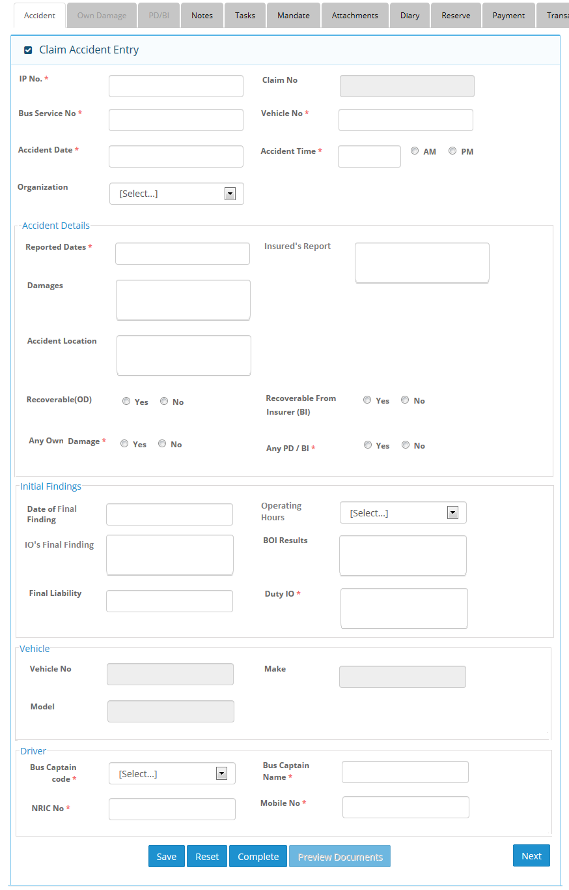

1) Accident Screen

2) OD PD BI Screen when OD selected
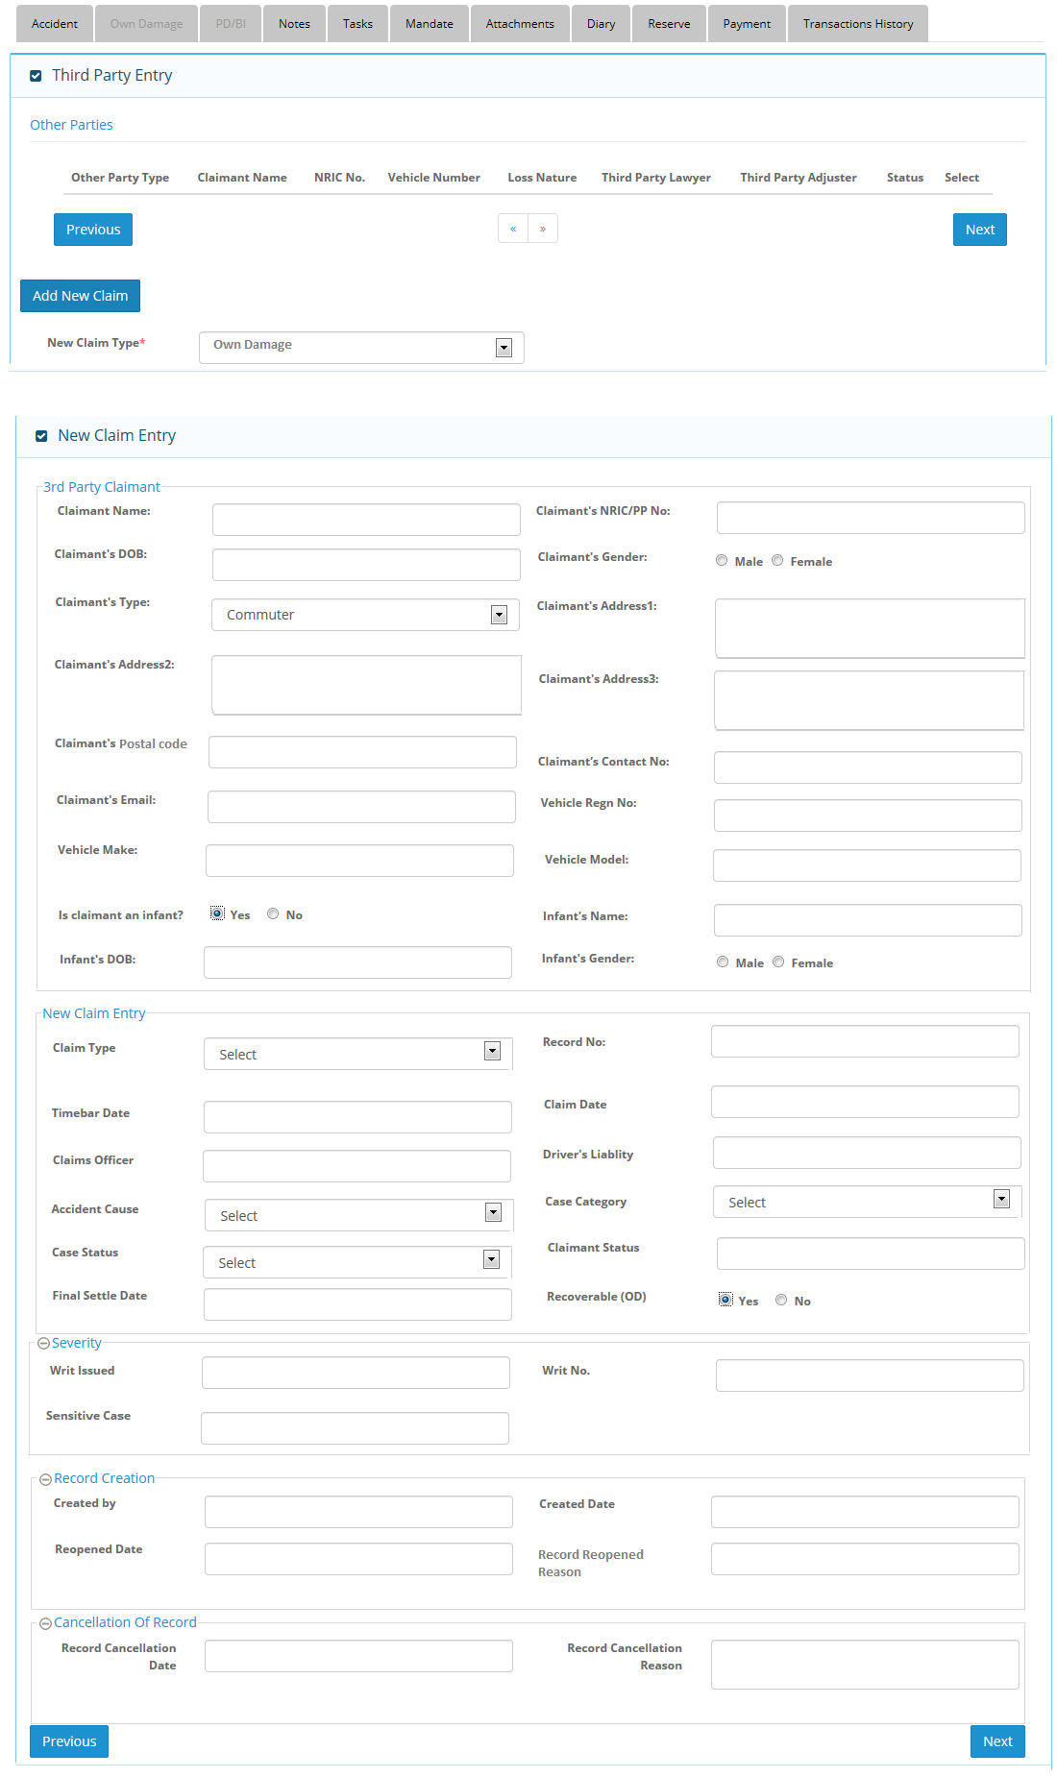

3) OD PD BI Screen when PD selected
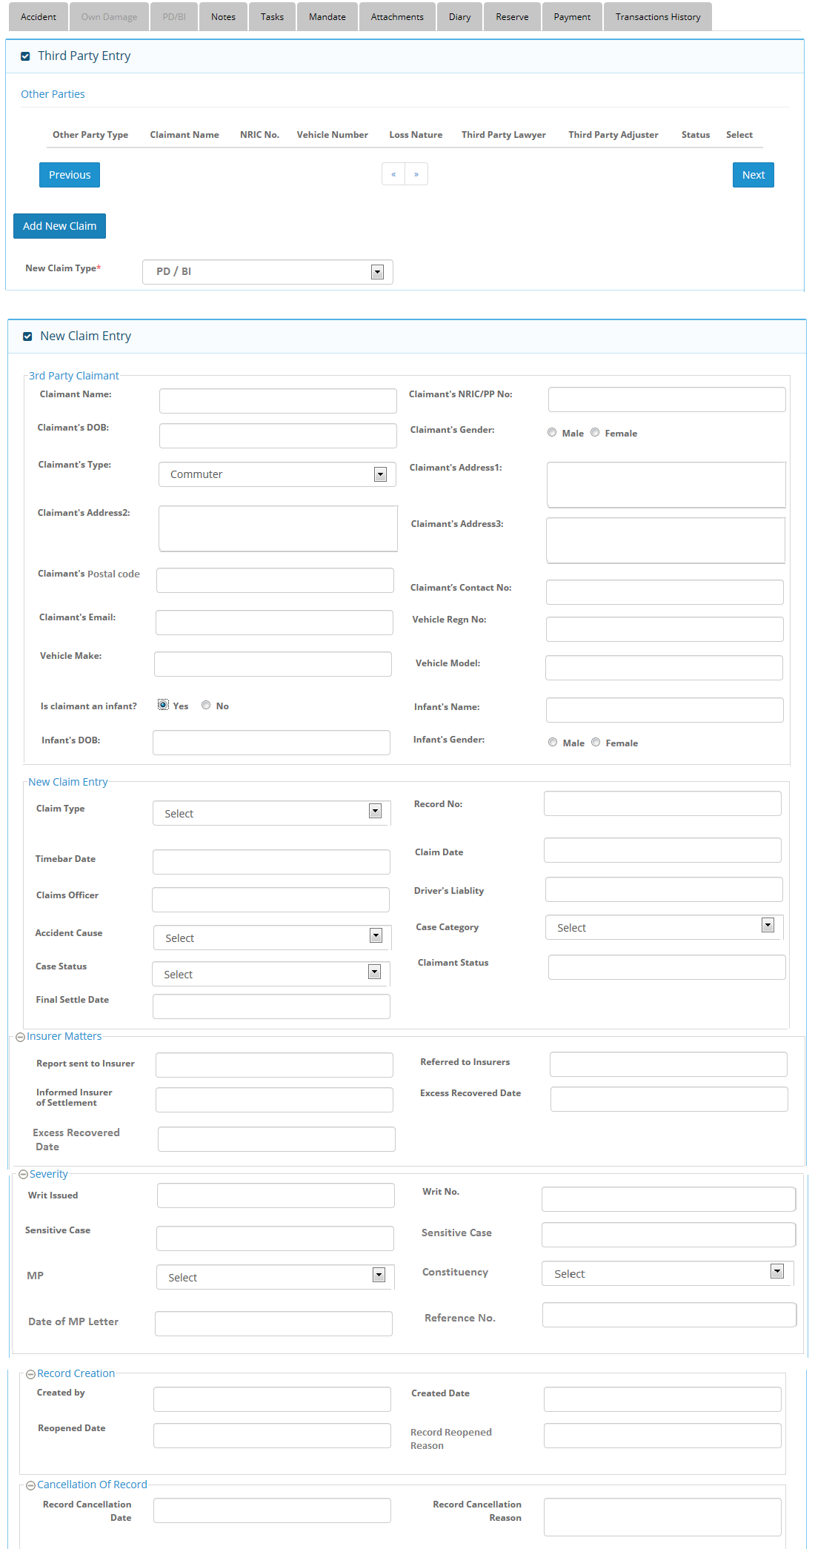
4) Service provider screen – when insurer selected
